Asymmetric DCC correlation: NZDUSD and USDCHF
Method 10 / GARCH(1,1) + Cappiello-Engle-Sheppard ADCC / Alpari D1 full available history

Study setup
Logical pair: NZDUSD , USDCHF
Broker symbols: NZDUSD_i , USDCHF_i
Snapshot: 2026-11-03_majors_alpari_D1
Timeframe: D1
Matched return window: 1999-01-05 to 2026-11-02 (UTC bar dates)
Matched return count n: 7185
Dropped unfinished last bar dated 2026-11-03 UTC after a tick-volume check against the prior complete day.
NZDUSD GARCH(1,1): mu=0.000013, omega=0.004878, alpha=0.040366, beta=0.950724
USDCHF GARCH(1,1): mu=-0.000342, omega=0.003457, alpha=0.040949, beta=0.956764
ADCC: a=0.049086, b=0.926231, g=0.000000, a+b+g/2=0.975317
Nested DCC (g=0): a=0.049086, b=0.926231
Negative shock: n = min(z, 0) in broker quote direction (not inverted)
Burn-in ignored in path summaries and chart: first 60 updates
Complete matched rows (Excel): NZDUSD-USDCHF_ADCC_D1.xlsx
Complete matched rows (HTML table): NZDUSD-USDCHF_ADCC_D1_data.html

Method carried forward
Asymmetric DCC extends Engle DCC with an extra term on joint negative standardised shocks. Each matched daily log return of close, ln(close_t / close_t-1), is first filtered by a constant-mean GARCH(1,1). Then z = residual / sigma and n = min(z, 0). The Cappiello-Engle-Sheppard recursion uses A = (1-a-b) Q_bar - g N_bar with N_bar = mean(n n'). Quotes are not inverted, so a negative shock is a negative log return in the broker quote. Nested symmetric DCC (g = 0) is fit on the same z path for comparison. Constraints: a,b,g >= 0 and a + b + g/2 < 1. Path summaries ignore the first 60 updates. The headline is latest ADCC rho. Pearson r is a side check only. This is not a cause, lead, or trading signal.

Results
Latest ADCC rho: -0.321299
Latest nested DCC rho: -0.321299
Post-burn-in ADCC path (n=7125): mean=-0.423579, median=-0.442041, min=-0.745854, max=0.209908, std=0.148824
Share of post-burn-in days with |rho| >= 0.4: 61.53%; |rho| >= 0.7: 0.34%
Same-sample Pearson r: -0.393600
ADCC minus r: 0.072301
ADCC minus nested DCC: 0.000000

Conclusion
Over 7185 matched daily log-return rows for NZDUSD and USDCHF (broker quote directions unchanged), latest ADCC rho is -0.3213 (negative, weak conditional linear link in this sample) with fitted a=0.0491, b=0.9262, g=0.0000. Nested symmetric DCC latest rho is -0.3213 (ADCC minus DCC = 0.0000). After a 60-day burn-in, path mean is -0.4236 and std is 0.1488. Same-sample Pearson r is -0.3936 (ADCC minus r = 0.0723). This does not establish cause, lead-lag, or a lasting trading rule.

Charts
Daily closes

Daily log returns
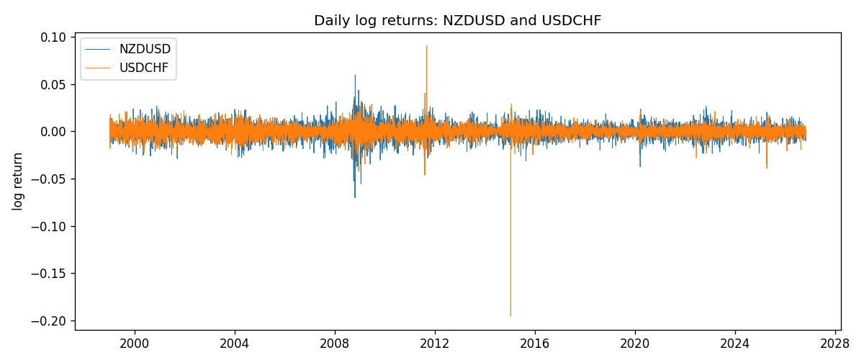
ADCC rho path with nested DCC and Pearson r
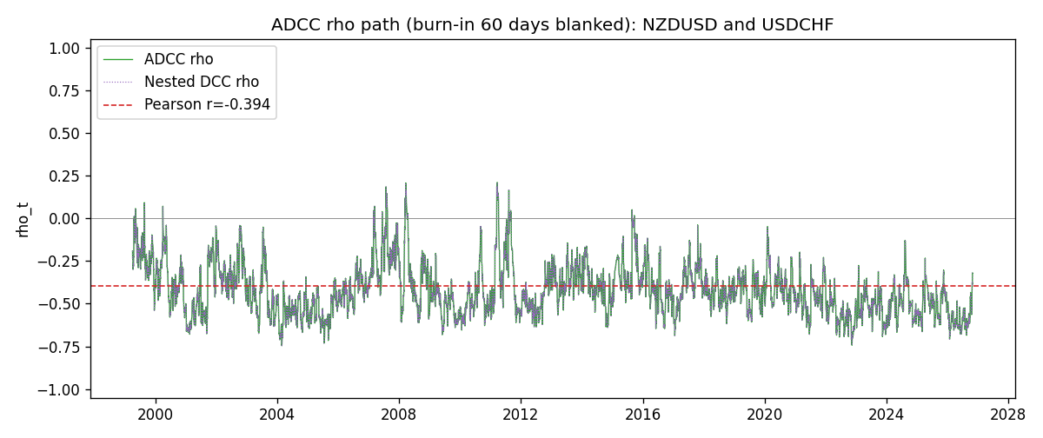

Data report
Every matched row that entered the ADCC recursion is stored in the sibling Excel workbook named NZDUSD-USDCHF_ADCC_D1.xlsx. Embedding all rows as a Word table is impractical at this length; the Word file holds the column list, column summaries, and the first and last 15 matched rows.
Columns: time, NZDUSD_open, USDCHF_open, NZDUSD_high, USDCHF_high, NZDUSD_low, USDCHF_low, NZDUSD_close, USDCHF_close, NZDUSD_tick_volume, USDCHF_tick_volume, NZDUSD_spread, USDCHF_spread, NZDUSD_real_volume, USDCHF_real_volume, NZDUSD_log_return, USDCHF_log_return, NZDUSD_sigma, USDCHF_sigma, NZDUSD_z, USDCHF_z, NZDUSD_n, USDCHF_n, q11, q22, q12, rho_adcc, rho_dcc
Column summaries (matched calculation rows)
column | count | mean | std | min | 25% | 50% | 75% | max
NZDUSD_open | 7185 | 0.65641395 | 0.10821881 | 0.3913 | 0.59137 | 0.6684 | 0.72499 | 0.88218
USDCHF_open | 7185 | 1.0976269 | 0.25248305 | 0.72022 | 0.92053 | 0.98988 | 1.2378 | 1.8219
NZDUSD_high | 7185 | 0.66033247 | 0.10871106 | 0.3961 | 0.59478 | 0.672 | 0.72937 | 0.88421
USDCHF_high | 7185 | 1.1029176 | 0.25422469 | 0.73305 | 0.92474 | 0.99353 | 1.2423 | 1.8313
NZDUSD_low | 7185 | 0.65272894 | 0.10781325 | 0.3897 | 0.58811 | 0.66417 | 0.72099 | 0.87988
USDCHF_low | 7185 | 1.0925083 | 0.25089773 | 0.08565 | 0.91719 | 0.98622 | 1.2317 | 1.8121
NZDUSD_close | 7185 | 0.65649284 | 0.10821292 | 0.3907 | 0.59165 | 0.6684 | 0.72502 | 0.8822
USDCHF_close | 7185 | 1.0976163 | 0.25237603 | 0.72025 | 0.92079 | 0.98995 | 1.2379 | 1.8217
NZDUSD_tick_volume | 7185 | 68718.644 | 123140.12 | 16 | 5587 | 33899 | 58511 | 1127682
USDCHF_tick_volume | 7185 | 74335.19 | 113494.16 | 18 | 12810 | 40241 | 70443 | 858589
NZDUSD_spread | 7185 | 30.278775 | 25.647496 | 0 | 9 | 17 | 40 | 80
USDCHF_spread | 7185 | 26.036326 | 24.697816 | 0 | 5 | 16 | 50 | 100
NZDUSD_real_volume | 7185 | 1.6703703e+10 | 8.4983725e+10 | 0 | 0 | 0 | 0 | 2.705649e+12
USDCHF_real_volume | 7185 | 2.3294091e+10 | 8.9133595e+10 | 0 | 0 | 0 | 0 | 1.9331921e+12
NZDUSD_log_return | 7185 | 2.019e-05 | 0.00763908 | -0.07027433 | -0.0042485 | 0.00023717 | 0.00458461 | 0.05966839
USDCHF_log_return | 7185 | -7.205e-05 | 0.00658891 | -0.19545699 | -0.0033516 | 8.095e-05 | 0.00331593 | 0.09051364
NZDUSD_sigma | 7185 | 0.00728249 | 0.00216648 | 0.00438979 | 0.00595062 | 0.00670058 | 0.00802988 | 0.02517264
USDCHF_sigma | 7185 | 0.00654569 | 0.00254562 | 0.00361855 | 0.00508474 | 0.00609474 | 0.00730665 | 0.03987387
NZDUSD_z | 7185 | -0.00220147 | 1.0000748 | -5.6253797 | -0.62968101 | 0.03192613 | 0.64759914 | 4.2270329
USDCHF_z | 7185 | 0.03933044 | 0.99909962 | -34.474716 | -0.48029327 | 0.07052851 | 0.59715194 | 6.7479863
NZDUSD_n | 7185 | -0.38939379 | 0.61540857 | -5.6253797 | -0.62968101 | 0 | 0 | 0
USDCHF_n | 7185 | -0.33059937 | 0.67931966 | -34.474716 | -0.48029327 | 0 | 0 | 0
q11 | 7185 | 1.0004384 | 0.22848771 | 0.61174612 | 0.85014997 | 0.95691754 | 1.0962182 | 2.9215584
q22 | 7185 | 1.0001171 | 1.8190692 | 0.52105377 | 0.75674406 | 0.85923352 | 0.98619825 | 59.090752
q12 | 7185 | -0.40114916 | 0.19747999 | -3.7854255 | -0.50116492 | -0.38784624 | -0.29221678 | 0.30060224
rho_adcc | 7185 | -0.42109403 | 0.15091129 | -0.745854 | -0.53221201 | -0.44084004 | -0.33867541 | 0.20990801
rho_dcc | 7185 | -0.42109402 | 0.15091125 | -0.74585394 | -0.532212 | -0.44084003 | -0.33867557 | 0.20990771
First 15 matched rows (selected columns)
time | NZDUSD_log_return | USDCHF_log_return | NZDUSD_z | USDCHF_z | NZDUSD_n | USDCHF_n | q11 | q22 | q12 | rho_adcc | rho_dcc
1999-01-05 | -0.0018597736 | 0.0039424743 | -0.31800335 | 0.51083375 | -0.31800335 | 0 | 1 | 1 | -0.40096749 | -0.40096749 | -0.40096749
1999-01-06 | 0.0020455609 | 0.013605652 | 0.35046317 | 1.6865186 | 0 | 0 | 0.95587771 | 0.96372291 | -0.38925942 | -0.40556631 | -0.40556631
1999-01-07 | 0.0062963171 | -0.0093883841 | 1.100093 | -1.0534702 | 0 | -1.0534702 | 0.91607539 | 1.0569309 | -0.34142815 | -0.34698478 | -0.34698482
1999-01-08 | -0.00055396548 | 0.011040268 | -0.098643813 | 1.3208576 | -0.098643813 | 0 | 0.9325846 | 1.0581208 | -0.38302509 | -0.38558088 | -0.38558088
1999-01-11 | 0.010290425 | 0.0052963193 | 1.8178113 | 0.64378869 | 0 | 0 | 0.88894925 | 1.090386 | -0.37106239 | -0.37689322 | -0.37689322
1999-01-12 | -0.0053157489 | -0.0098275602 | -0.8990361 | -1.0951475 | -0.8990361 | -1.0951475 | 1.0102574 | 1.0549765 | -0.29614163 | -0.28685474 | -0.28685482
1999-01-13 | -0.0099742238 | -0.018259701 | -1.6872518 | -2.0578816 | -1.6872518 | -2.0578816 | 1.0000893 | 1.0607062 | -0.23586348 | -0.22900437 | -0.2290045
1999-01-14 | -0.00018564931 | -0.0024256692 | -0.03237709 | -0.22468704 | -0.03237709 | -0.22468704 | 1.090736 | 1.2150157 | -0.057925839 | -0.050317792 | -0.050318059
1999-01-15 | -0.00074294208 | 0.01794228 | -0.12528405 | 2.0089708 | -0.12528405 | 0 | 1.0350077 | 1.152546 | -0.063192781 | -0.057858417 | -0.057858671
1999-01-18 | -0.0018597736 | -0.0031856384 | -0.31587951 | -0.29445413 | -0.31587951 | -0.29445413 | 0.98410948 | 1.2903166 | -0.080782869 | -0.071688488 | -0.071688705
1999-01-19 | 0.0018597736 | -7.2518946e-05 | 0.31633404 | 0.028383338 | 0 | 0 | 0.94109335 | 1.2240698 | -0.080155143 | -0.074681312 | -0.074681521
1999-01-20 | 0.0040793678 | 0.0072259871 | 0.70765379 | 0.81420346 | 0 | 0 | 0.9012646 | 1.1584937 | -0.083698603 | -0.081911564 | -0.08191176
1999-01-21 | 0.0040627941 | -0.0038232689 | 0.70985774 | -0.37686812 | 0 | -0.37686812 | 0.88404315 | 1.1302561 | -0.059139204 | -0.059163018 | -0.059163222
1999-01-22 | -0.012051689 | -0.0001445609 | -2.1299702 | 0.021702523 | -2.1299702 | 0 | 0.86824546 | 1.0785327 | -0.077805394 | -0.080402914 | -0.08040309
1999-01-25 | -0.0035504102 | 0.0024546976 | -0.58693994 | 0.3140667 | -0.58693994 | 0 | 1.0515716 | 1.0236763 | -0.084231964 | -0.08118507 | -0.081185222
Last 15 matched rows (selected columns)
time | NZDUSD_log_return | USDCHF_log_return | NZDUSD_z | USDCHF_z | NZDUSD_n | USDCHF_n | q11 | q22 | q12 | rho_adcc | rho_dcc
2026-10-13 | 0.0047326165 | -0.0024955621 | 0.95743291 | -0.45083981 | 0 | -0.45083981 | 0.72008398 | 0.69458394 | -0.34868019 | -0.49302998 | -0.49303
2026-10-14 | -0.0037306483 | 0.0029388325 | -0.75667508 | 0.69354938 | -0.75667508 | 0 | 0.73664325 | 0.67800522 | -0.35404342 | -0.50096964 | -0.50096965
2026-10-15 | 0.0047634855 | -0.0097855323 | 0.96296661 | -2.0046951 | 0 | -2.0046951 | 0.7350894 | 0.67628339 | -0.36358304 | -0.5156668 | -0.51566679
2026-10-16 | 0.0057501001 | -0.0036230826 | 1.1582417 | -0.6532751 | 0 | -0.6532751 | 0.75106336 | 0.84834529 | -0.44141753 | -0.55299979 | -0.55299976
2026-10-19 | 0.0018917133 | 0.0036351779 | 0.37461095 | 0.79654653 | 0 | 0 | 0.78619137 | 0.83139502 | -0.45589267 | -0.56389048 | -0.56389045
2026-10-20 | 0.0037199341 | -0.0026281224 | 0.74836142 | -0.45874132 | 0 | -0.45874132 | 0.75976616 | 0.82589124 | -0.41751184 | -0.5270689 | -0.52706889
2026-10-21 | 0.0030923331 | -0.00040027413 | 0.62376307 | -0.011879694 | 0 | -0.011879694 | 0.75589235 | 0.79997884 | -0.41346091 | -0.53169825 | -0.53169823
2026-10-22 | -0.0033035227 | -0.0048036381 | -0.67661286 | -0.91805952 | -0.67661286 | -0.91805952 | 0.74391232 | 0.76565503 | -0.39322105 | -0.5210259 | -0.52102589
2026-10-23 | 0.0030929853 | 0.005652514 | 0.63148922 | 1.2296916 | 0 | 0 | 0.73618948 | 0.77522782 | -0.34361963 | -0.4548503 | -0.45485036
2026-10-26 | -0.0028993932 | 0.0018407959 | -0.60114103 | 0.44046931 | -0.60114103 | 0 | 0.72613897 | 0.81694819 | -0.29005096 | -0.3765886 | -0.37658872
2026-10-27 | -0.00026399852 | 0.0026100526 | -0.057667964 | 0.60214161 | -0.057667964 | 0 | 0.71499367 | 0.79088901 | -0.29154849 | -0.38770547 | -0.38770557
2026-10-28 | -0.0097283914 | -0.0010142111 | -2.0536318 | -0.13816447 | -2.0536318 | -0.13816447 | 0.68709549 | 0.77502622 | -0.28164279 | -0.38595076 | -0.38595084
2026-10-29 | 0.00062190714 | -0.0048680164 | 0.11998572 | -0.94312081 | 0 | -0.94312081 | 0.86810836 | 0.74347326 | -0.25683569 | -0.31969491 | -0.31969505
2026-10-30 | 0.00019537668 | 0.00071594559 | 0.036415721 | 0.21947246 | 0 | 0 | 0.82945842 | 0.75697194 | -0.25334089 | -0.31971874 | -0.31971887
2026-11-02 | -0.0025962955 | -0.0071459744 | -0.53042244 | -1.4309878 | -0.53042244 | -1.4309878 | 0.79301809 | 0.72817819 | -0.24415695 | -0.32129851 | -0.32129863

